**CHAPTER 9**

**LED & BUZZER**

**9.1 LED**

A **light-emitting diode** (**LED**) is a two-lead [semiconductor](http://en.wikipedia.org/wiki/Semiconductor) light source that resembles a basic [pn-junction](http://en.wikipedia.org/wiki/Pn-junction" \o "Pn-junction) diode, except that an LED also emits light. when an LED's anode lead has a voltage that is more positive than its cathode lead by at least the LED's forward voltage drop, current flows. [Electrons](http://en.wikipedia.org/wiki/Electrons) are able to recombine with [holes](http://en.wikipedia.org/wiki/Electron_hole) within the device, releasing energy in the form of [photons](http://en.wikipedia.org/wiki/Photon). This effect is called [electroluminescence](http://en.wikipedia.org/wiki/Electroluminescence), and the color of the light (corresponding to the energy of the photon) is determined by the energy [band gap](http://en.wikipedia.org/wiki/Band_gap) of the semiconductor.

Early LEDs were often used as indicator lamps for electronic devices, replacing small incandescent bulbs. They were soon packaged into numeric readouts in the form of [seven-segment displays](http://en.wikipedia.org/wiki/Seven-segment_display), and were commonly seen in digital clocks. Recent developments in LEDs permit them to be used in environmental and task lighting. LEDs have many advantages over incandescent light sources including lower energy consumption, longer lifetime, improved physical robustness, smaller size, and faster switching. Light-emitting diodes are now used in applications as diverse as [aviation lighting](http://en.wikipedia.org/wiki/Navigation_light#Aviation_navigation_lights), [automotive headlamps](http://en.wikipedia.org/wiki/Automotive_lighting#Light_emitting_diodes_.28LED.29), advertising, [general lighting](http://en.wikipedia.org/wiki/Lighting), [traffic signals](http://en.wikipedia.org/wiki/Traffic_signal), and camera flashes. However, LEDs powerful enough for room lighting are still relatively expensive, and require more precise current and heat management than compact [fluorescent lamp](http://en.wikipedia.org/wiki/Fluorescent_lamp) sources of comparable output.

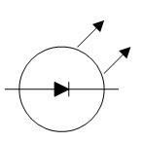The  low maintenance and small size of LEDs has led to uses as status indicators and displays on a variety of equipment and installations. Large area [LED displays](http://en.wikipedia.org/wiki/LED_display) are used as stadium displays and as dynamic decorative displays. Thin, lightweight message displays are used at airports and railway stations, and [low energy consumption](http://en.wikipedia.org/wiki/Energy_conservation), as [destination displays](http://en.wikipedia.org/wiki/Destination_sign) for trains, buses, trams, and ferries.

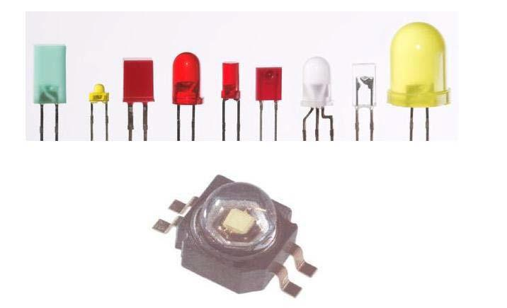

**Figure :** Light Emitting Diodes **Figure:** LED representation

**9.2 BUZZER**

A buzzer or beeper is an [audio](http://en.wikipedia.org/wiki/Sound) signalling device, which maybe [mechanical](http://en.wikipedia.org/wiki/Machine), [electromechanical](http://en.wikipedia.org/wiki/Electromechanics), or [piezoelectric](http://en.wikipedia.org/wiki/Piezoelectricity). Typical uses of buzzers and beepers include [alarm devices](http://en.wikipedia.org/wiki/Alarm_devices), [timers](http://en.wikipedia.org/wiki/Timer) and confirmation of user input such as a mouse click or keystroke.

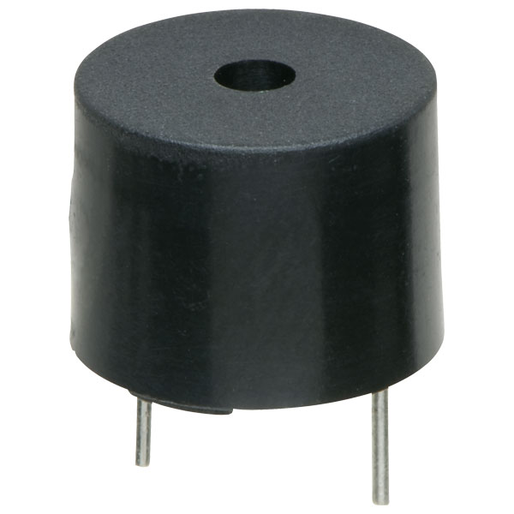 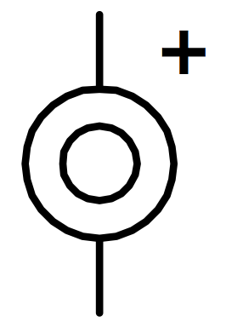

**Figure:** A typical buzzer **Figure:** Electronic symbol for a buzzer

**MECHANICAL**

A [joy buzzer](http://en.wikipedia.org/wiki/Joy_buzzer) is an example of a purely mechanical buzzer.

**ELECTROMECHANICAL**

Early devices were based on an electromechanical system identical to an [electric bell](http://en.wikipedia.org/wiki/Electric_bell) without the metal gong. Similarly, a [relay](http://en.wikipedia.org/wiki/Relay) may be connected to interrupt its own actuating [current](http://en.wikipedia.org/wiki/Electric_current), causing the [contacts](http://en.wikipedia.org/wiki/Switch) to buzz. Often these units were anchored to a wall or ceiling to use it as a sounding board. The word "buzzer" comes from the rasping noise that electromechanical buzzers made.

**PIEZOELECTRIC**

A piezoelectric element may be driven by an [oscillating](http://en.wikipedia.org/wiki/Oscillation) electronic circuit or other [audio signal](http://en.wikipedia.org/wiki/Audio_signal) source, driven with a [piezoelectric audio amplifier](http://en.wikipedia.org/wiki/Piezoelectric_audio_amplifier). Sounds commonly used to indicate that a button has been pressed are a click, a ring or a beep.

**USES**

* [Annunciator panels](http://en.wikipedia.org/wiki/Annunciator_panel)
* Electronic [metronomes](http://en.wikipedia.org/wiki/Metronome)
* [Game shows](http://en.wikipedia.org/wiki/Game_show)
* [Microwave ovens](http://en.wikipedia.org/wiki/Microwave_oven) and other [household appliances](http://en.wikipedia.org/wiki/Major_appliance)
* [Sporting](http://en.wikipedia.org/wiki/Sport) events such as [basketball](http://en.wikipedia.org/wiki/Basketball) games
* Electrical [alarms](http://en.wikipedia.org/wiki/Alarms)

**9.3 CONCLUSION**

We can use LEDs for several purposes, in which the most common is the indicator of power supply, which shows the presence of a power supply. If power supply is turned on the LED also turned on otherwise it remains turned off. Due to their lower energy consumption, longer lifetime, improved physical robustness, smaller size, and faster switching it suits to our needs.

Buzzer is an electronic device used to make large annoying sound against something. It makes huge and sharp sound which gets attention of everyone around the buzzer. Best uses are in the field of theft alarm system. Here we can use the buzzer as an alert to the user about an unauthorized access of a person in the surveillance area.